Time for Walk Kansas!

Gather your team-mates – it’s time for Walk Kansas! K-State Research and Extension (KSRE) has been offering this health initiative since 2001. Online registration is available February 18 through March 16, and information about Walk Kansas and healthful living is available at www.walkkansas.org.

Here is a step-by-step guide that covers options for registering your team followed by general program information.

Register online:
▪ Before you go to register, recruit team members (at least 4 – you can add more later). You will need their email address, or mailing address if they do not have email. If your team decides they all want t-shirts or the baseball tee, know their sizes. You will be asked to pay the program fee (plus shirts) for your entire team at the end of registration, so be prepared to pay with credit card (PayPal) or follow up by sending a check. Talk to your team and select a goal for how many minutes of exercise each person will commit to per week – 2 ½ hours, 4 hours or 6 hours.
▪ When you are ready, go to www.walkkansasonline.org and follow these steps. If you reach a point during the process where you don’t have the needed information, click CANCEL and start again later. (Please do not exit out of the system without selecting CANCEL.)
- Click the yellow “Register” button
- Ready to Go! (Notice the link that will help you locate all KSRE offices in Kansas.)
- Select the county or district where you will participate
- Pick your Challenge. You have 3 options based on the goals your team goals: “8 Wonders Walk” = 2 ½ hrs/wk; “Cross Country” = 4 hrs/wk; “Little Balkans to Nicodemus” – 6 hr/wk
- Choose one of the options:
Challenge Only ($8 each) – each person can order a shirt later;
Challenge + t-shirt ($17 each) – enter color and size for each person;
Challenge + baseball tee ($22 each) – enter size for each person.
(Note: If you select “Challenge + shirt” each person will pay that amount even if they do not want a shirt.)
- Choose “Captain” if you are registering a team. Choose “Individual” if you do not have a team and would like to be placed on one.
- Enter the name of your team. (You can change the name later.)
- Create your personal user account. Select a username and password; then complete the required personal information.
- Now you are ready to build your team. Complete the required information for at least 4 people. Then confirm your team.

Important dates:

February 18 – Registration opens online

March 16 – Registration closes

March 18 – Go! Log exercise minutes and cups of fruits/vegetables

April 2 – Last day to order Walk Kansas apparel

May 5 – Walk Kansas 5K for the Fight! In Manhattan on the K-State campus

May 11 – Photo Challenge entries due

May 12 – Walk Kansas ends. Plan to attend the Walk Kansas Celebration event!
Kansas State University Agricultural Experiment Station and Cooperative Extension Service
K-State Research and Extension is an equal opportunity provider and employer.
Guide for Captains 2018 March 18 – May 12
10) Complete the next page by giving your consent to participate. You must consent and choose from the authorization statements to continue. Note: Each team mate that you entered will receive a message asking them to create a user profile and consent, just like you completed. Each person must do this before your team is ready to go.
11) Order summary -- pay online or select “Pay with Check.”
12) Congratulations – you are registered for Walk Kansas! Please note the name(s) of your local Extension Agent(s) and/or program coordinators if you have further questions.

Register with paper forms:
▪ Distribute participant information to each team member.
▪ Select a team challenge and complete the Team Registration Form (available from your local Extension Office.)
▪ Collect registration forms, program fees, and payment for t-shirts (optional). Return forms and payment (one check per team) to the Extension Office before March 16. Registration is not complete until all forms are collected and fees are paid.
Ready to go!
Reporting/logging online:
Once your team is “ready” (everyone has added user information, consented and all fees are paid) you will see a screen like this when you log in. A new feature this year allows the captain to e-mail their team in addition to using the “Team Chat” feature. You will record your personal exercise minutes, fruits/veg here and you can also view how others on your team are doing by clicking on “My Team.” Check for “Events” in your area and “Resources” located on the top bar.
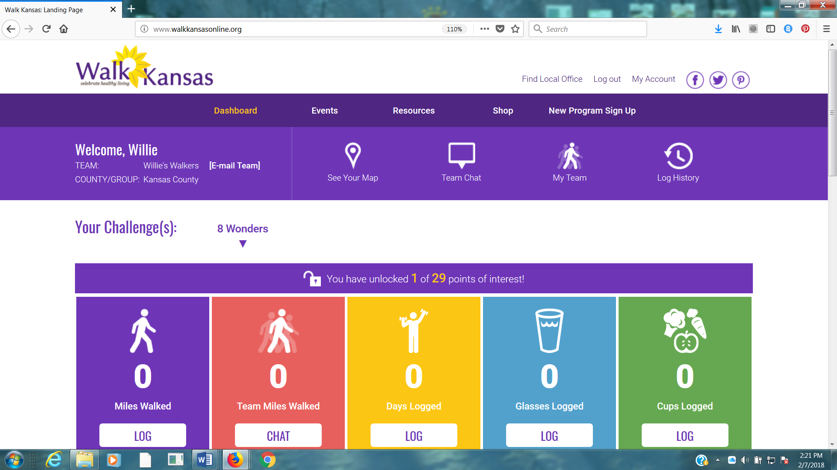

Make sure you and your team-mates check your progress on the map – click “See Your Map” on the large purple bar. Are your team moves along the trail you will unlock points of interest. Some will have photos and all have a description of the town/community, area of interest, or Wonders of Kansas. You can go back and click on any dot you have passed through to read the information. Enjoy!!

Scroll down a bit further and you will see a “Leaderboard” at the bottom. You can view how other teams in your county/district are doing and at the very bottom you will see recent posts from “Kansas State University Walk Kansas” on Facebook. Be sure to like this page to see more.

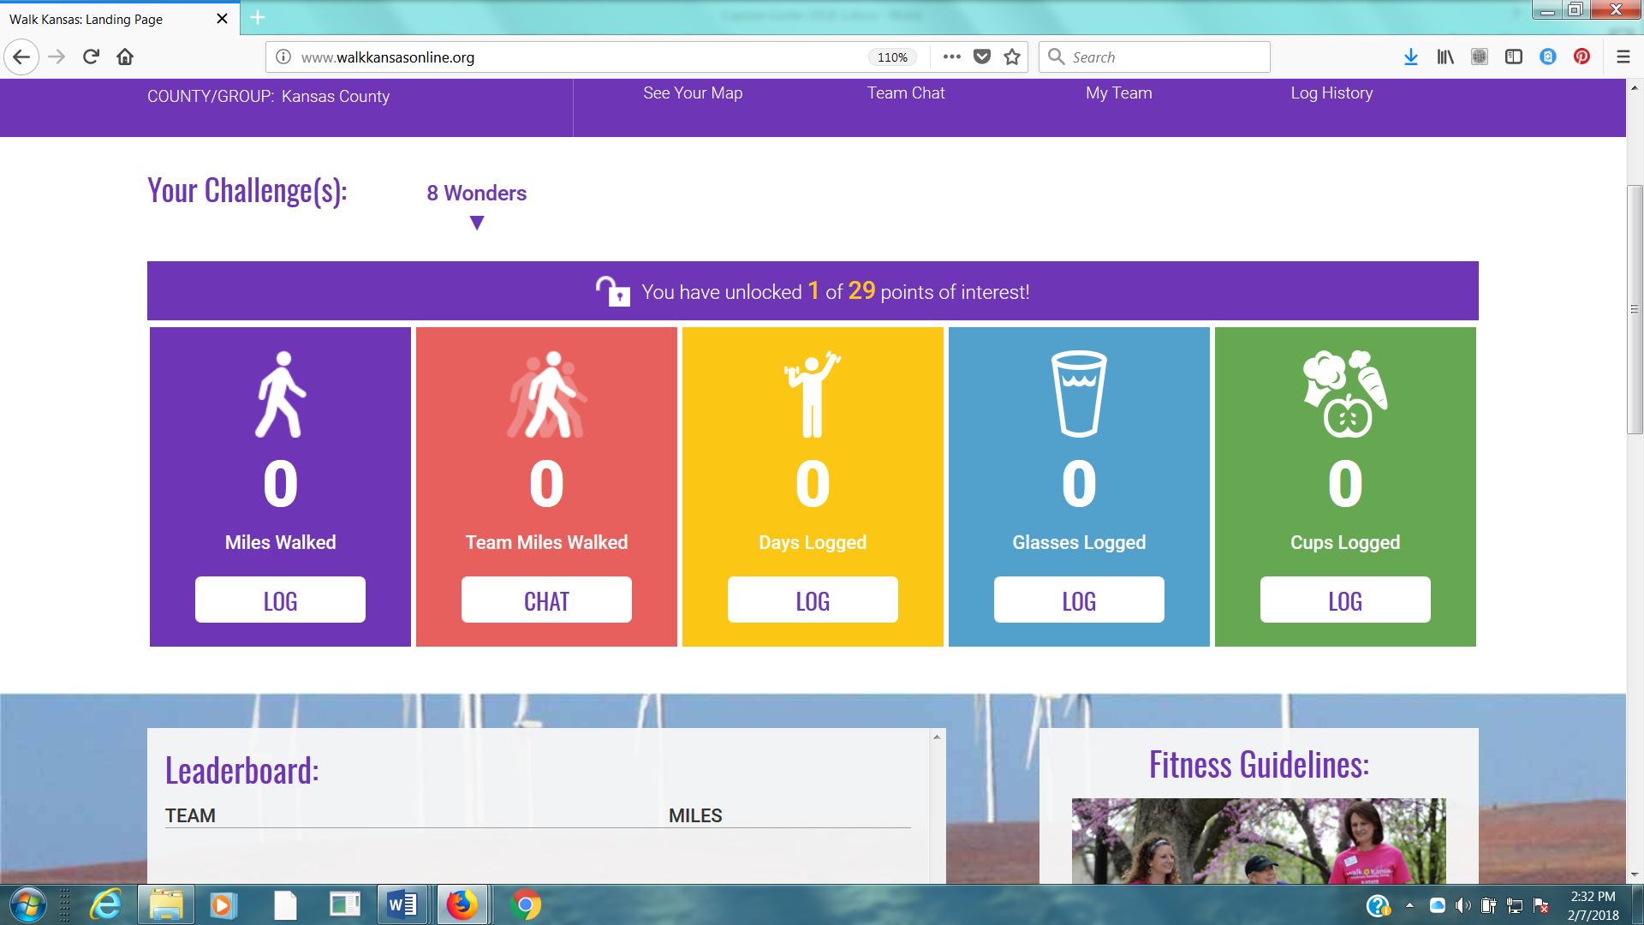

You can also view how teams in any county/district across the state are doing through the blue “Leaderboard” button on the login page.
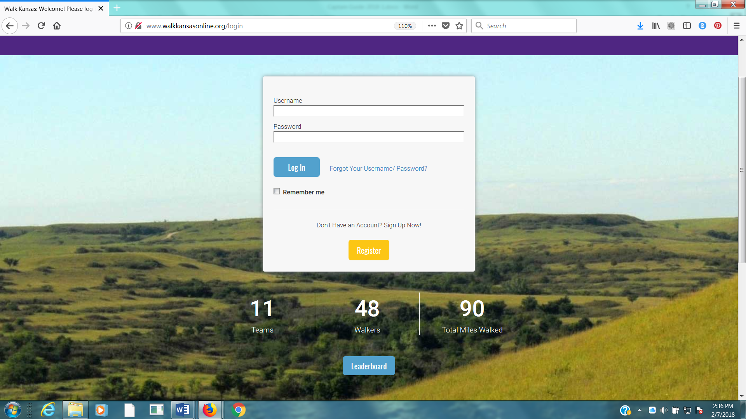

Reporting if logging by paper:
If team mates log on paper and report to you weekly, add totals once a week for that person in the “My Team” section and “Log for this user.” If you want to report only one number (total minutes of activity) for your entire team, report it as minutes for you – the captain – only.

Reminders for captains:
► Communicate with your team mates each week (email, chat in Walk KS system, phone call or in person.) All Walk Kansas participants will receive a message on Wednesday of each week that includes a short report of how their team is doing. Everyone will also receive a weekly newsletter.
► Make sure team-mates are receiving a weekly Walk Kansas newsletter. If not, report this to your local office.
► Stay informed of events and activities offered in your community and participate when you can!
► Plan a fun activity(s) your team can do together during the 8 weeks of Walk Kansas.
► Encourage team mates to enter the photo contest – that includes you!

How to order t-shirts and more:
If you did not include a shirt at registration, you can easily order one. Sign in to your account and click the “Shop” button on the purple bar at the top of the screen. This will take you to the online store for your county/district. Just shop from here and it will be added to your account. (Tax is charged on anything that ordered through the store.) Other team members can do the same once they have created a username/password.

Captains also participate:
Not only are you the captain of your team, you are a Walk Kansas participant! Make sure you read through the participant materials, especially the Activity Guide. There is new information here about pre/post fitness tests that your team may want to do and this is an activity you could do together. These are optional and can be very helpful and motivating. Make sure you also review what counts as Walk Kansas minutes as there are a few changes from previous years.

One last thing …. While Walk Kansas is sometimes viewed as a (friendly) competition, but what we are really working toward is helping your team reach the goal they set for themselves. We want the physical activity and healthy eating habits that are modeled and adopted during the program to continue as a lifestyle change. Keep it realistic, keep it fun and don’t worry about what others are doing or reporting. Be honest, be supportive to others and have a great Walk Kansas!!

