Ready to Walk!
What is one of the best things you can do for your body, mind and spirit? You guessed it – walk every day!! K-State Research and Extension (KSRE) is so pleased to offer this health initiative designed to help you move more, eat better and live life to the fullest. Regular exercise, like walking, can help you live longer, maintain a healthy weight, reduce your risk of developing some cancers, reduce your risk of heart disease and stroke, reduce diabetes risk, boost your brain power, improve your mood and relieve stress. Wow – there isn’t a pill that can offer all of those benefits!!

Walk Kansas is a team-based program, meaning that you are part of a 6-member team and together you will select a goal (challenge) to work toward during the 8 weeks. Here are the options for your team.
Challenge 1: Discover the 8 Wonders of Kansas! This journey requires each person to get 2 ½ hrs of moderate activity per week.
Challenge 2: Go Cross Country from Troy (NE) to Elkhart (SW), which requires 4 hrs of activity per person/week.
Challenge 3: Little Balkans to Nicodemus – a trail that takes you through SE Kansas and then up to Nicodemus with interesting stops along the way. This requires 6 hrs of activity per person/week.

Each person logs minutes of moderate/vigorous activity and these are converted to Walk Kansas miles (15 minute = 1 mile) on the website. For a complete description of activities that count for Walk Kansas and how to report minutes, check your Activity Guide.

Take the first step – register for Walk Kansas!
To register online at www.walkkansasonline.org:
If you already have a team, wait for your captain to register the team online. You will receive a message by email asking you to complete registration and give your consent to participate. Your captain will be responsible for paying fees for the entire team, so make sure you reimburse your captain for your registration fee (and t-shirt, if appropriate).

If you don’t have a team, and would like to join one, go online and register as an individual. The Extension office will connect you with a team that has similar goals.

Register with paper forms:
Complete the registration form provided by your captain. Return it, along with payment for the program fee and t-shirt (optional) to your captain. You can log minutes of activity and fruit/veg consumption on a paper or electronic log, or you can log online at www.walkkansasonline.org.

For specific information about Walk Kansas in your community, contact your local Extension Office. Find contact information here: http://www.ksre.k-state.edu/about/stateandareamaps.html

All program participants receive:
▪ Weekly newsletter (information on health and wellness, exercise/activity, stress management, nutrition and a tasty recipe.)
▪ Access to interactive online system for activity reporting
▪ Local events, classes and celebrations that support Walk Kansas

Kansas State University Agricultural Experiment Station and Cooperative Extension Service
K-State Research and Extension is an equal opportunity provider and employer.
March 18 – May 12, 2018 Participant Guide
Healthy Eating is Important
Here is a sobering statistic – according to the Centers for Disease Control and Prevention (CDC), only 10% of Kansans eat enough fruits and vegetables. While recommendations vary based on age and gender, most adults need
1½-2 cups of fruit and 2-3 cups of vegetables each day. We ask you to log the cups of fruits/veggies you eat daily as a way to help you increase that amount and we know that F/V consumption in Kansas increases during this program! Our goal is to help you make this a lifestyle habit. Check your newsletter each week for tips on increasing your fruits and veggies plus other healthy eating strategies – including a tasty recipe!

Report/Log online:
Once your team is “ready” (everyone has added user information, consented and all fees are paid) you will see a screen like this when you log in. This is your “Dashboard” and you can log here and you will find links to other features of the online system. Along the top of the horizontal purple bar: Click on “Events” to see what is happening in your community; “Resources” is where you will find program newsletters and other resources to support healthy lifestyle habits; “Shop” is where you can purchase additional merchandise such as t-shirts, sweatshirts, tote bag, water bottle, etc. (The Shop will only be open the first 2 weeks of Walk Kansas.)
Also on the purple bar -- This is where you see your welcome message, your team name and the group where you are participating. Once you start logging minutes, click on the “See Your Map” icon and you will be see a map of Kansas with your challenge trail displayed. This is where you will unlock points of interest along the trail and learn more about our great state. Click “Team Chat” to communicate with team members. “My Team” shows all of your team mates and “Log History” shows what you have logged for activity, f/v, etc.
To log your progress: In the purple box, log your minutes of activity – the system will calculate into miles. (Read the Activity Guide to know what counts); the red box displays the total miles your team was walked and this also takes you to the “team chat” page; if you do strengthening exercises that day, click “log” in the yellow box; the blue box is where you can log the number of 8 oz. glasses of water you drink – this is optional; and record cups of fruits/veggies in the green box.

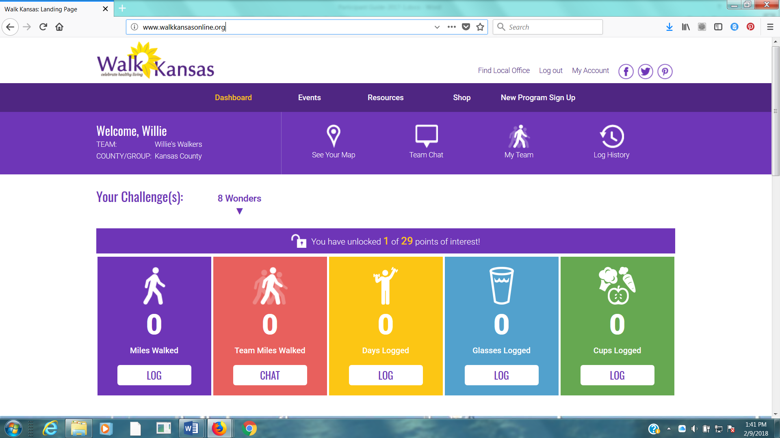

If you scroll down the page, you will see a white “Leaderboard” box. This is where other teams from your community, that chose the same challenge as your team, will appear along with their progress. At the bottom of the page you will see recent posts on the Facebook group Kansas State University Walk Kansas. Please like our page on Facebook!

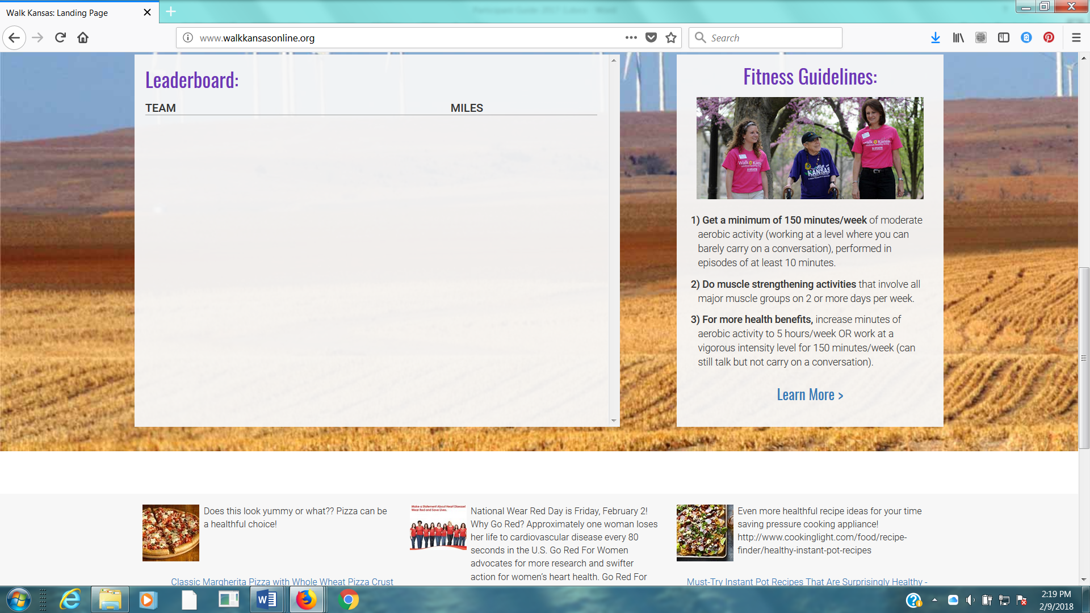

You can see how all teams, in all 3 challenges, in your community and across Kansas are doing by going to the “Leaderboard” located on the login page, www.walkkansasonline.org. Click on the blue box at the bottom of this screen.
